RESULTS
RQ1: What are the interrelations among the targeted disciplines based on job descriptions?
- Ability and Skills

Educational Technology jobs have a dominant discourse over the ability and skills concept. It mainly defined five different skills and abilities. These are learning skills, reasoning skills, organizational skills, business skills, and language ability. On the other hand, Educational Technology and Instructional Systems Technology positions had a mutual acceptance on the definition of learning skills.

Table 1. Coding relations of the job categories and word cloud of ability and skills theme
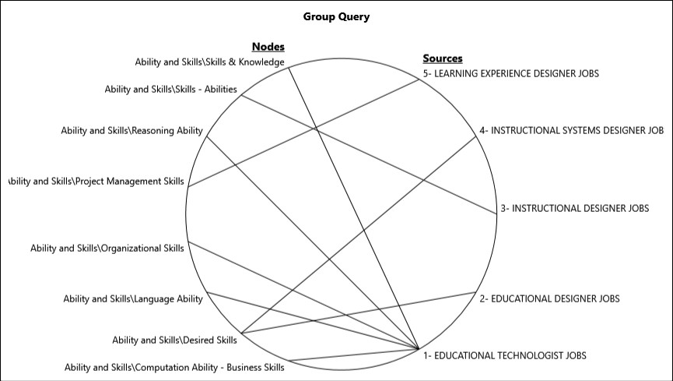 | 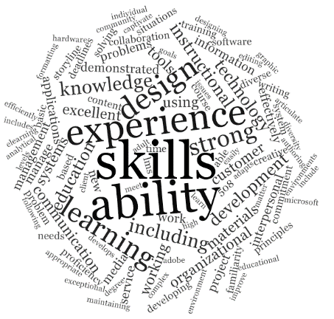

- Experience

Learning Experience Design dominated the discourse on the work experience such as experience with client-facing, in responsive design for multiple platforms, and direct experience with vendors. In addition, learning experience in designing and developing learning materials and innovative curriculum and certification programming are the other concentration points. In a similar manner, Instructional Design has a dominant discourse on three points: (1) the familiarity with specific software such as Captivate, Storyline, and Adobe Creative Suite as well as Internet and e-mail applications and Learning Management Systems.

Table 2. Coding relations of the job categories and word cloud of experience theme
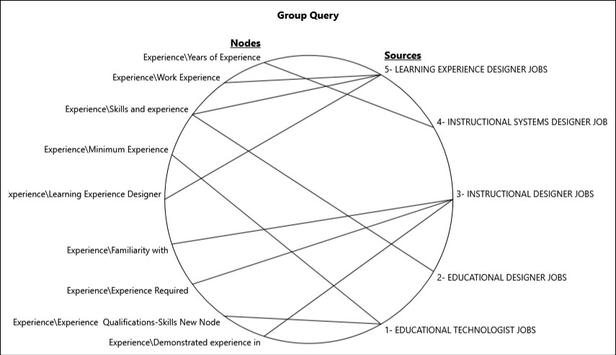 | 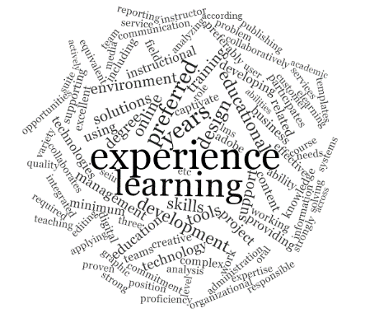

- Preferences

Educational Technology positions were dominated by discourse on the preferred experiences such as Microsoft products, storyline, agile framework, familiarity with flipped learning, visual design, and classroom management. The rest of the jobs had negotiated discourse on the preferred experiences. One of the significant findings in these negotiated categories is about the “What you will do” section of the Educational Design. This discourse can be interpreted as the unpredictability of the tasks and the continuously changing demands of the market.

Table 3. Coding relations of the job categories and word cloud of preferences theme
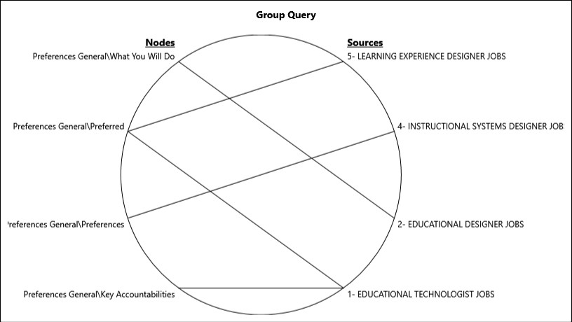

- Qualifications

Educational Design, Learning Experience Design, Instructional Systems Design, and Instructional Design positions had a mutual understanding on the qualifications. Degree, certification, higher communication skills, and specific years of experience were some of the examples in this category.

Table 4. Coding relations of the job categories and word cloud of qualifications theme

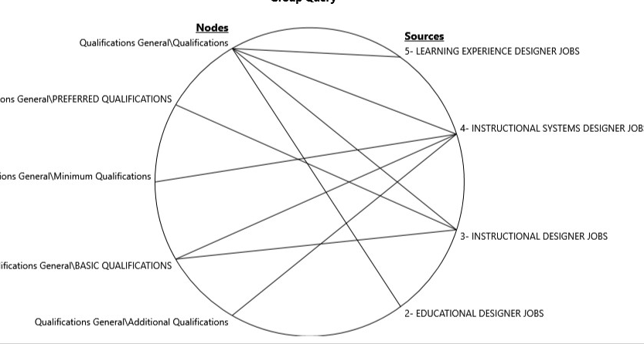 | 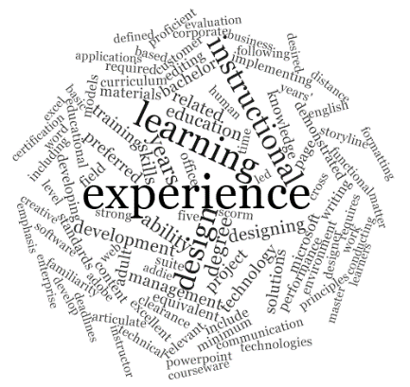

- Requirements

Job postings for Educational Technology, Learning Experience Design, Instructional Systems Design, and Instructional Design had a mutual understanding on the general requirements. Examples include having a degree/certification, knowledge of learning theories and instructional design models, strong communication skills, strong organization skills, specific number of years’ experience in the field, and experience with specific software. Instructional Design also has a negotiated requirement on the physical abilities such as constantly performing desk-based computer tasks, rarely writing by hand, and using a telephone.

Table 5. Coding relations of the job categories and word cloud of requirements theme

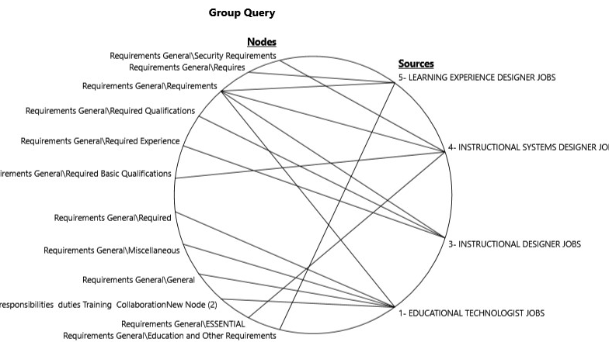 | 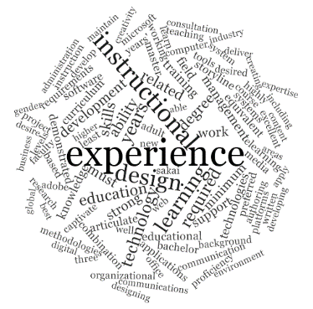

- Responsibilities

Learning Experience Design, Instructional Systems Design, and Instructional Design related job announcements had a mutual understanding on the general responsibilities. Examples include the development of training and instruction, conducting evaluation and needs analysis, being familiar with specific software, and supporting learning. Furthermore, Educational Technology positions had a negotiated discourse on the “other duties may be assigned.".

Table 6. Coding relations of the job categories and word cloud of responsibilities theme

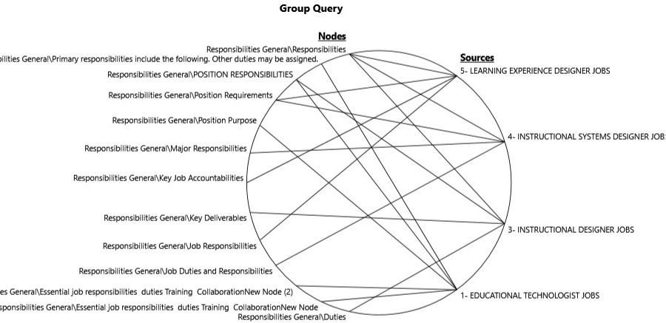

RQ2: What are the expected roles of professionals working in the targeted disciplines based on Twitter job announcements and the content of the announced job?
Message Channel
- Considering these two findings and Stuart Hall’s (1980) communication model, we can locate the Educational Technology and Instructional Design to the message channels.
- According to Hall (1980), when selecting a channel, the availability, suitability, and cost of the channel, type of message that is sent or received, and the communication skills of the sender and receivers are considered. In other words, they focus on increasing the efficiency and effectiveness of the to carry the message accurately to the learner.
Sender
- Educational designers are expected to investigate research methods and apply appropriate learning theory to the design of learning materials and learning events to ensure that the desired goals are fulfilled (AECT, 2004).
- In effect, they plan the educational event or experience to transmit the values, rules, and beliefs.
Receiver
- Learning Experience Design has a dominant discourse on the work experience such as experience with client-facing, in responsive design for multiple platforms, and in direct experience with vendors. Also deemed important is experience in designing and developing learning materials and innovative curriculum and certification programming.

- Learning Experience Design is the practical side of education. The specific teaching-learning processes that occur in a lesson, a unit of learning, or a course is the major concern of this field (Walsh, 2017). They accomplish these goals by considering the existing standards as defined by educational designer and the tools studied as well as methods that are proven effective by instructional designers and educational technologists.

Feedback
- Instructional Systems Design has a mutual discourse with other fields at Requirements and Qualifications, as a result, it is in the feedback loop. Its systematic nature also contributes to this claim.

